

SCHOOL OF ADVANCED SCIENCES

(SAS)

**Assignment - 5**

Program: M.Sc. DATA SCIENCE

Course: Database Management Systems Lab

Submitted by: SOUMYADEEP GANGULY Course code: PMDS506P

Register number: 24MDT0082

1. **Write a PL/SQL block that computes the total salary of the employees in the employee table. (use for loop)**

DECLARE

s NUMBER := 0;

BEGIN

FOR i IN (SELECT * FROM employee) LOOP

s := s + i.salary;

END LOOP;

DBMS_OUTPUT.PUT_LINE(s);

END;

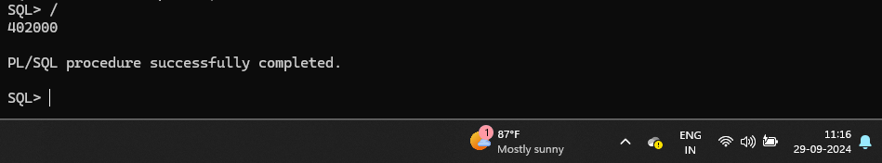

1. **Write a PL/SQL block that checks if an employee's salary is greater than or equal to 70,000. If it is, print "High salary". Otherwise, print "Regular salary". (use if else)**

BEGIN

FOR i IN (SELECT * FROM employee) LOOP

if i.salary >= 70000 then

dbms_output.put_line('High Salary');

else

dbms_output.put_line('Regular Salary');

end if;

END LOOP;

END;

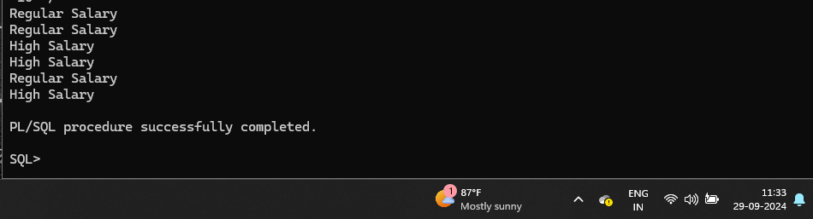

1. **Write a PL/SQL block that uses a FOR loop to display the salaries of employees in the 'IT' department. (for loop)**

BEGIN

FOR i IN (SELECT * FROM employee where department='IT') LOOP

dbms_output.put_line(i.salary);

END LOOP;

END;

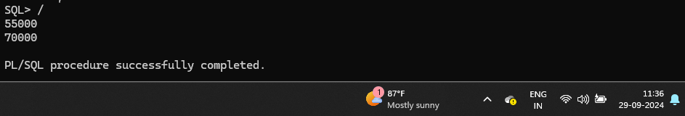

1. **Write a PL/SQL block that increases the salary of all employees in IT department by 5% and prints the updated salaries. (for loop)**

DECLARE

sal NUMBER :=0;

BEGIN

FOR i IN (SELECT * FROM employee where department='IT') LOOP

sal := i.salary + i.salary * 0.05;

dbms_output.put_line(sal);

END LOOP;

END;

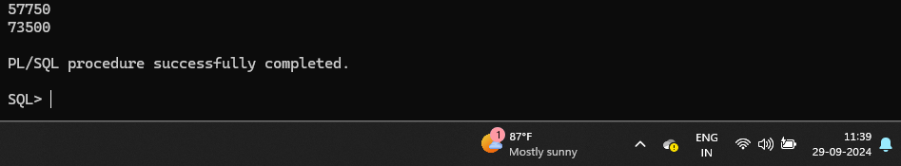

1. **Categorize employees into 'High', 'Medium', or 'Low' salary brackets based on their salary. (Use case expression)**

DECLARE

sal varchar(10);

BEGIN

FOR i IN (SELECT * FROM employee) LOOP

sal :=

case

when i.salary >= 72000 then 'High'

when i.salary >= 65000 and i.salary <= 70000 then 'Medium'

else 'Low'

end;

dbms_output.put_line(sal);

END LOOP;

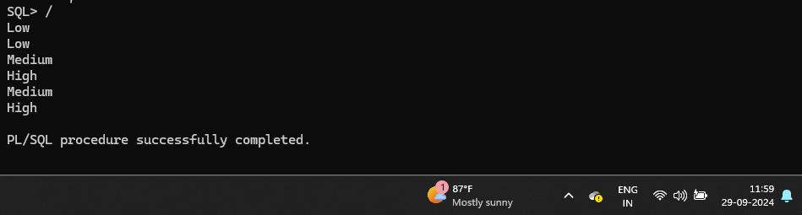END;

1. **Create a SQL query that uses a CASE expression to display different messages based on the department of employees. Display 'Welcome to HR' for employees in the 'HR' department, 'Tech Team' for employees in the 'IT' department, and 'Finance Team' for employees in the 'Finance' department.**

DECLARE

sal varchar(50);

BEGIN

FOR i IN (SELECT * FROM employee) LOOP

sal :=

case i.department

when 'HR' then 'Welcome to HR'

when 'IT' then 'Welcome to Tech Team'

else 'Welcome to Finance Department'

end;

dbms_output.put_line(sal);

END LOOP;

END;

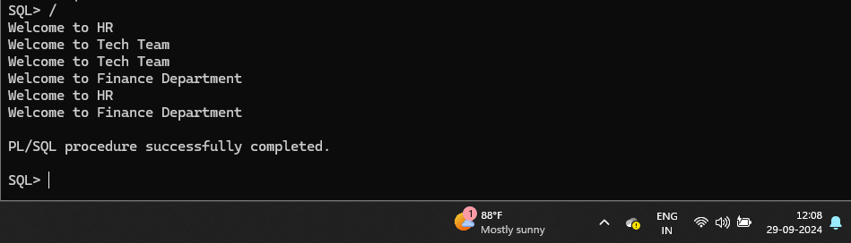

1. **Create a PL/SQL procedure increase_salary that takes an emp_id and a percentage increase and updates the salary of the employee by the given percentage.**

CREATE OR REPLACE PROCEDURE increase_salary

(e_id IN employee.emp_id%TYPE,

percent_increase IN NUMBER)

IS

current_sal employee.salary%TYPE;

new_salary employee.salary%TYPE;

BEGIN

SELECT salary INTO current_sal FROM employee WHERE emp_id = e_id;

new_salary := current_sal + current_sal * (percent_increase / 100);

UPDATE employee SET salary = new_salary WHERE emp_id = e_id;

END increase_salary;

/

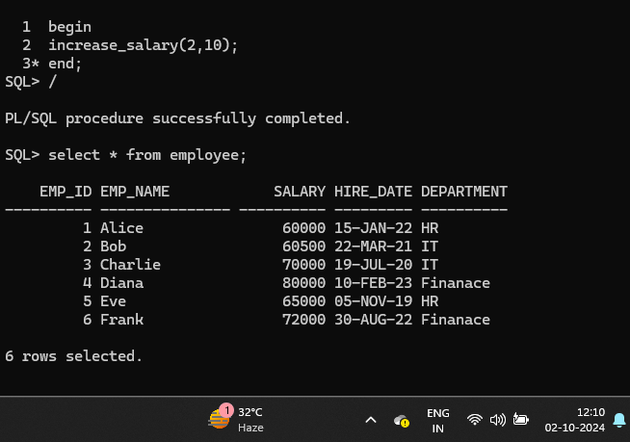

1. **Write a PL/SQL function get_employee_department that takes an emp_id and returns the department of the employee.**

CREATE OR REPLACE FUNCTION get_employee_department

(e_id NUMBER)

RETURN employee.department%TYPE

IS

emp_dept employee.department%TYPE;

BEGIN

SELECT department INTO emp_dept FROM employee WHERE emp_id = e_id;

RETURN emp_dept;

END;/

/

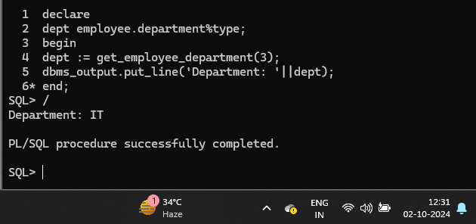

1. **Create a procedure update_salary that takes an emp_id and a new salary and updates the employee's salary in the employee’s table.**

create or replace procedure update_salary

(e_id in employee.emp_id%type,

new_sal in employee.salary%type)

is

begin

update employee set salary= new_sal where emp_id = e_id;

end update_salary;

/

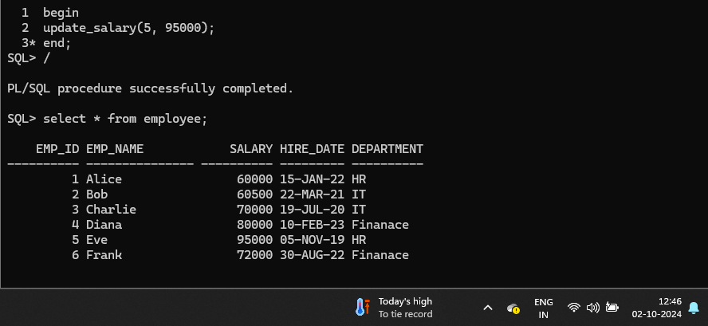

1. **Write a function calculate_bonus that takes a salary and returns a bonus amount based on the following criteria: 10% of salary if the salary is above 70000. 5% of salary if the salary is between 60000 and 70000. 1% of salary if below 60000.**

CREATE OR REPLACE FUNCTION calculate_bonus

(salary employee.salary%type)

RETURN employee.salary%type

IS

bonus employee.salary%type;

BEGIN

if salary > 70000 then

return salary+salary*0.1;

elsif salary >=60000 and salary <=70000 then

return salary+salary*0.05;

else

return salary+salary*0.01;

end if;

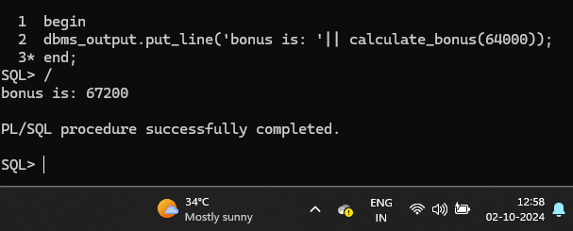

1. **Create a procedure promote_employee that takes an emp_id and updates the employee’s department to 'Management' if their salary is greater than or equal to 70000.**

CREATE OR REPLACE PROCEDURE promote_employee

(e_id IN employee.emp_id%TYPE)

IS

current_sal employee.salary%TYPE;

BEGIN

SELECT salary INTO current_sal

FROM employee

WHERE emp_id = e_id;

IF current_sal >= 70000 THEN

UPDATE employee SET department = 'Management' WHERE emp_id = e_id;

dbms_output.put_line('Promoted');

ELSE

dbms_output.put_line('Salary is below 70000');

END IF;

END;/

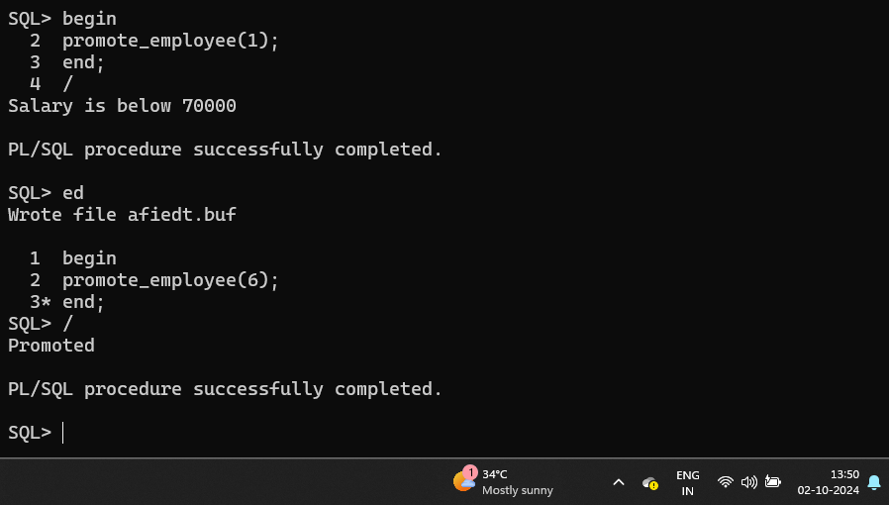

1. **Create a function get_employee_details that takes an emp_id and returns the employee's name, salary, and hire date.**

CREATE OR REPLACE PROCEDURE get_employee_details

(e_id IN employee.emp_id%TYPE)

IS

emp_name employee.emp_name%TYPE;

salary employee.salary%TYPE;

hire_date employee.hire_date%TYPE;

BEGIN

SELECT emp_name, salary, hire_date INTO emp_name, salary, hire_date FROM employee WHERE emp_id = e_id;

dbms_output.put_line('Name: ' || emp_name || ', Salary: ' || salary || ', Hire Date: ' || hire_date); END; /

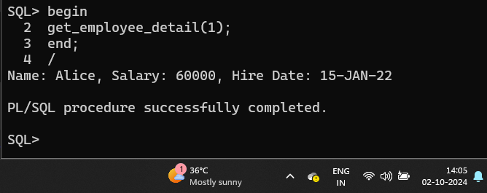

1. **Write a function compare_salaries that takes two emp_ids and returns the name of the employee with the highest salary.**

CREATE OR REPLACE FUNCTION compare_salaries

(e_id1 employee.emp_id%TYPE,

e_id2 employee.emp_id%TYPE)

RETURN employee.emp_name%TYPE

IS

name1 employee.emp_name%TYPE;

name2 employee.emp_name%TYPE;

sal1 employee.salary%TYPE;

sal2 employee.salary%TYPE;

result_name employee.emp_name%TYPE;

BEGIN

SELECT emp_name, salary

INTO name1, sal1

FROM employee

WHERE emp_id = e_id1;

SELECT emp_name, salary

INTO name2, sal2

FROM employee

WHERE emp_id = e_id2;

IF sal1 > sal2 THEN

result_name := name1;

dbms_output.put_line(name1 || ' has the higher salary.');

ELSE

result_name := name2;

dbms_output.put_line(name2 || ' has the higher salary.');

END IF;

RETURN result_name;

END;

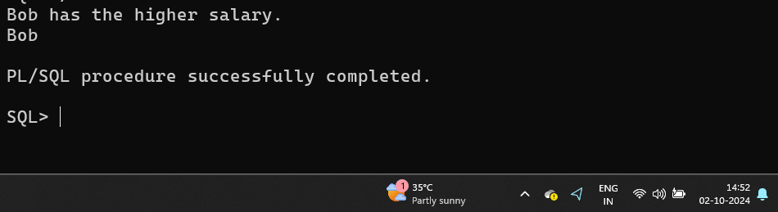 /

1. **Create a function count_employees_in_department that takes a department name and returns the number of employees in that department.**

CREATE OR REPLACE FUNCTION count_employees_in_department

(dept employee.department%TYPE)

RETURN NUMBER

IS

cnt NUMBER;

BEGIN

SELECT COUNT(emp_id)

INTO cnt

FROM employee

WHERE department = dept;

RETURN cnt;

END;

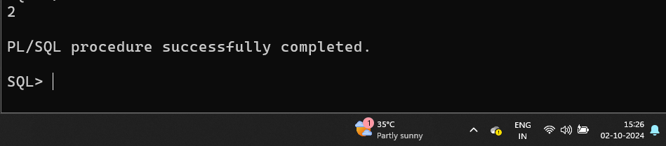

1. **Write a procedure check_hire_date that takes an emp_id and prints a message indicating if the employee was hired in on or after 2022.**

create or replace procedure check_hire_date

(e_id employee.emp_id%type)

is

h_date date;

begin

select hire_date into h_date from employee where emp_id = e_id;

if h_date >= to_date('01-JAN-2022', 'DD-MON-YYYY') then

dbms_output.put_line('Hired after 01-JAN-2022');

else

dbms_output.put_line('Hired before 01-JAN-2022');

end if;

end;

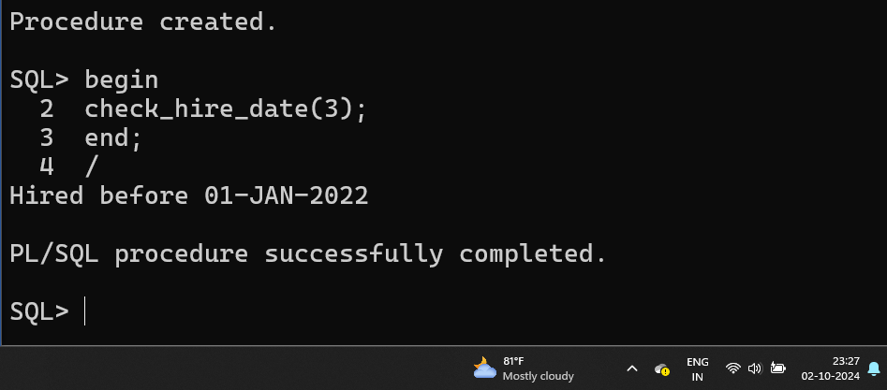

1. **Create a procedure increase_salary_by_department that takes a department name and a percentage increase and increases the salary of all employees in that department by the given percentage.**

CREATE OR REPLACE PROCEDURE increase_salary_by_department (

dept IN employee.department%TYPE,

percentage IN NUMBER

)

AS

BEGIN

FOR i IN (SELECT employee_id, salary FROM employee WHERE department = dept)

LOOP

UPDATE employee

SET salary = i.salary + i.salary * (percentage / 100) WHERE emp_id = i.emp_id;

END LOOP;

END;

/

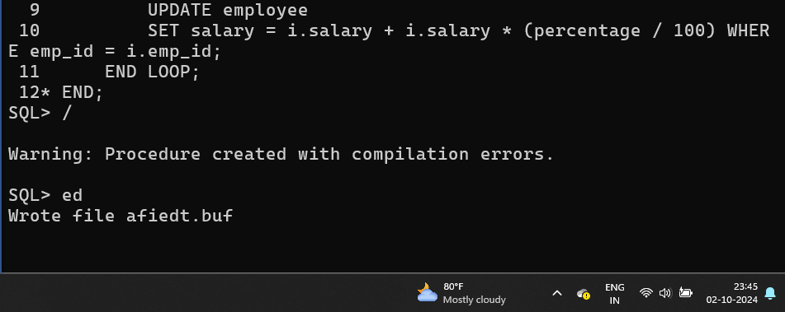

1. **Write a function highest_salary_in_department that takes a department name and returns the highest salary in that department. (using aggregate functions).**

CREATE OR REPLACE FUNCTION highest_salary_in_department (

dept_name IN employee.department%TYPE

)

RETURN NUMBER

IS

v_highest_salary NUMBER;

BEGIN

SELECT MAX(salary) INTO v_highest_salary FROM employee WHERE department = dept_name;

RETURN v_highest_salary;

END;

/

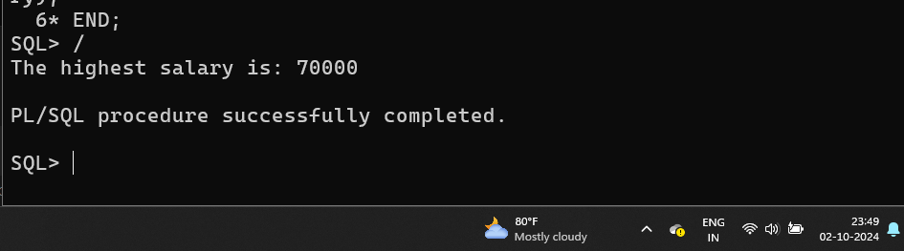

1. **Write a function highest_salary_in_department that takes a department name and returns the highest salary in that department. (Without using aggregate functions)**

CREATE OR REPLACE FUNCTION highest_salary_in_department (

dept_name IN employee.department%TYPE

)

RETURN NUMBER

IS

v_highest_salary employee.salary%TYPE := 0;

BEGIN

FOR emp_rec IN (SELECT salary FROM employee WHERE department = dept_name)

LOOP

IF emp_rec.salary > v_highest_salary THEN

v_highest_salary := emp_rec.salary;

END IF;

END LOOP;

RETURN v_highest_salary;

END;

/

